**Helpful Tips For Keeping A Happy Barn Cat**

[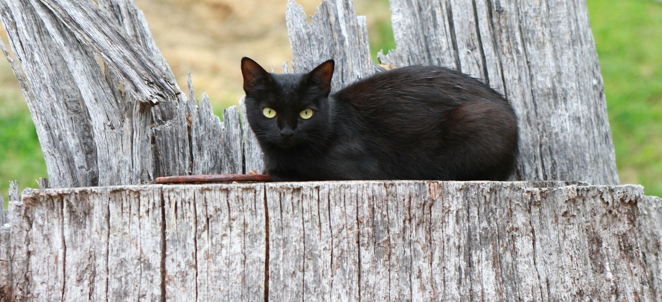](https://www.google.com/url?sa=i&rct=j&q=&esrc=s&source=images&cd=&cad=rja&uact=8&ved=2ahUKEwjFr4nB09HcAhUCRa0KHYqPAF8QjRx6BAgBEAU&url=https://commons.wikimedia.org/wiki/File:Black_barn_cat_-_Public_Domain.jpg&psig=AOvVaw0arzhIlzsShqOQLe_4QQxL&ust=1533411969126592)

**Imprinting Period**

* New barn cats must be confined to a kennel or small tack room for a minimum of 2 weeks. This 2 weeks in a confined area is called imprinting. This allows the cat time to become used to its new surroundings in a safe and controlled environment. Once the cat has been imprinted in the kennel, the cat can then be allowed to roam the closed up barn for a minimum of 7 days. During this time do not open any doors to the barn, this way the cat has time to find all safe areas in the barn. After this 7 days is up, you can then open the cat door first to allow the cat to use the cat door. Once the cat knows where the cat door is you can then start opening all doors to the barn as needed.
* If the weather is cold, keep the cat in a non-drafty area and provide a heat lamp or other source of safe heat to keep the cat warm. If the weather is hot, have a fan blowing on the cat to keep the cat cool. Freezing a milk jug with water in it and placing it with the cat inside the kennel or tack room will also help keep the cat cool. These cool and hot weather tips should be used during imprinting and can also be used once the cat is released from confinement.
* Once the imprinting period is done the cat will know exactly where its food, water and shelter will be, making it less likely for the cat to run off once released from confinement.

**Food & Water**

* Barn cats must be provided with fresh food and water daily. You may have heard from someone that barn cats eat mostly mice and that they do not need to be fed daily. This is far from the truth! Yes, barn cats will most likely kill mice, but they do not always eat them.
* For many cats, chasing and killing mice is a fun game. But not all cats eat mice and even if they do, the mice have very few calories that will not sustain a healthy cat. Although most barn cats are feral or semi feral, remember that they are still domestic cats and are not as capable of hunting and feeding as their wilder cousins who hunt the plains, forests and jungles.
* Providing fresh food and water daily will keep your barn cats healthy and close to home so that they do not need to wander far to find fresh food and water.
* Provide 2 bowls of food and 2 bowls of water if you have more than 1 barn cat. If one of the cats guards the food and water, the other cat(s) can go to the alternate food and water bowls.

**Other Helpful Tips**

* Lighter color cats have a lower survival rate when outdoors since their color does not blend in with the natural environment. Because of this, they need access to enclosed areas for protection from predators.
* If the cats roam far, cat houses can be put on different parts of the property to provide safety from weather and predators.
* Coyotes, stray dogs, bobcats and birds of prey are just a few predators that will prey on cats. Always be sure that barn cats have a safe place to hide and escape to when predators are near.
* Rat poison, machinery fluids, cleaning products and other chemicals need to be stored in leakproof containers and kept in a safe area away from cats. Some of these chemicals have an enticing smell and taste that can attract cats into ingesting chemicals which can be fatal to the cat.
* Food and water need to be placed in a dry, safe area away from predators.
* If your barn cat becomes injured or sick, consult with your veterinarian for proper treatment.
* Do not use cheap flea medications, these can cause the cat to have seizures. Use name brand flea medications. Ask your veterinarian or one of volunteers for good flea medication recommendations.

**Kitty Cat Connection, Inc. Barn Cat Program**

**Ashley Pope 816-885-7469 Britney James 573-356-2411 Tina Damman 816-588-0368**